IDSC Service Unit Match

The University of Miami Institute for Data Science and Computing (IDSC) is committed to providing exceptional advance computing resources to meet the computational needs of the Unviersity of Miami’s research community. In FY2020, IDSC transititioned to a partial fee-for-service model with the expectation that FY2021 services would be offered at the full service rate. We understand this model will impose added financial responsibility on investigators; and as such, IDSC will establish a Service Unit Match program designed to assist our heaviest users. This document establishes the criteria for eligbilty for a Service Unit Match subsidy and provides details on how to submit a request.

Advanced Compute Processing
The approved FY2021 rate for advanced compute processing on UM supercomputing systems is $0.011 per service unit (SU). As a rule of thumb, 1 SU equates to either (a) use 1 core for one hour or (b) 2 GB of RAM for 1 hour or (c) 1 GB of scratch space for four (4) hours. Users are reminded that data on these systems is not backed up and should should promptly remove the data from scratch space to avoid incurring additional usage charges.

Crtieria for Eligibility
This program is specifally designed to aid heavy users who have allocated greater than 275,000 SUs or $3025.00 in their proposal budget. This budget line item is referenced below as the User Contribution. IDSC will match each user contributed dollar as outlined in the table below. The IDSC SU Match is applied as the thresholds, defined below, are met.

Tier | Description | User Contribution | IDSC SU Match
Tier 1 | Less than 275,000 SU | Less than $3,025.00 | 0
Tier 2 | Greater than 275,001 SU | Above $3025.01 | 4/5 of the Rate of Service

Budgeting for Service Units
The IDSC Advanced Computing team can provide guidance to approporiately estimate resource ultilization on outgoing proposals. For assistance, email hpc@ccs.miami.edu. We recommend using the following text as the budget justification for this line item on outgoing proposals:

The project will utilize the resources of the Univeristy of Miami Institute for Data Science and Computing. Requested in the budget are funds to cover the cost for using the advanced computing infrastructure, calculated using the University’s approved subsided rates.

Subsidy Application Process
To submit an application, users will complete a New Project Request form for each project they need considered. Applications are routed to the Allocations Committee and processed on a first come, first serve basis. An award notice will be delivered via email summarizing the subsidy details.

Invoicing
A Workday Internal Service Delivery (ISD) document will be used to facilitate the transfer of funds.
Users will receive a monthly statement summarizing usage for each project account. The first $3025 will be due from the user. Tier 2 usage begins at 275,0001 SU, at which time monthly usage will be split, charging one fifth (1/5) utlization to the project account and the balance (4/5) to IDSC’s match program.

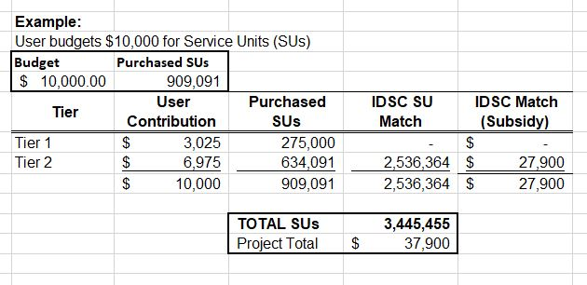

Please direct any inquries to Evelyn Cruz at ecruz3@miami.edu. For additional information on IDSC services and resources, please visit https://idsc.miami.edu/. IDSC FY2021 Fee Schedule is available for download.

PLEASE NOTE: There is a separate subsidy program and process for users without grant funding. Please visti our website for details or contact idsc@miami.edu.

